Senior Surgeons Cultural Extension to
Siem Reap, Cambodia

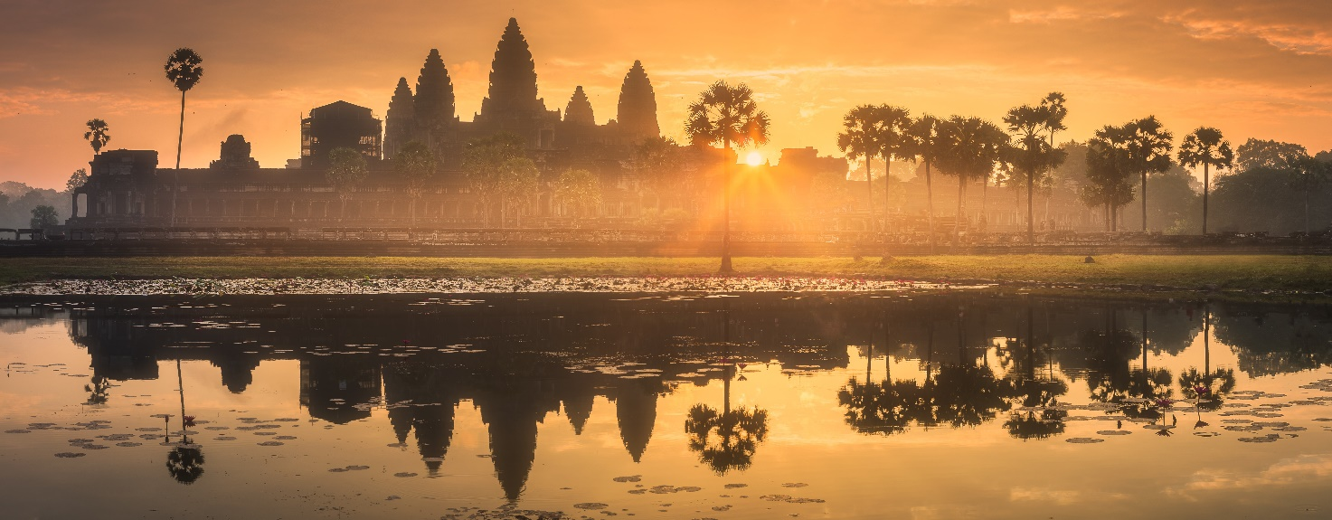

$2150 per person based on double occupancy, $695 Single supplement*

*(The Program fee is based on double occupancy; a single supplement is charged for those wishing a single room.)

Enroll for the Optional Cultural Extension:
Cultural Extension Registration Form

Day 1, January 4, 2024 Arrive at Siem Reap
Transfer from the Ho Chi Minh City hotel and arrive at Siem Reap International airport by flight, you will be welcomed by your local English-speaking guide and transferred to the Sokha Palace Siem Reap Hotel and Resort. The Sokha Palace is the perfect combination of luxury and tranquility set amidst lush tropical gardens. The setting offers the authenticity of traditional Cambodian design infused with fresh modern features and 5-star facilities.

Siem Reap is the base for exploring the fabled temples of Angkor, the ancient capital of the Khmer Empire.

Afternoon, visit the spectacular temples at the ancient city of Angkor Thom, the last capital of the Great Khmer Empire under the reign of Jayavarman VII. This city is surrounded by an 8 m high wall, drawing a perfect square. Enter the city through the ancient South Gate, an impressive stone gate carved with Elephants and four giant faces. On each side of the entrance path lies a row of 54 gods or demons, holding the sacred Naga snake welcome you.

From here, continue to Bayon Temple in the exact center of the city. This 12th century masterpiece is a study in grandeur and is well-known for its 54 towers with enigmatic faces representing the 54 provinces of the Great Khmer Empire. The Terrace of the Elephants and the Terrace of the Leper King are also must-visits as they are both known for their intricate bas-reliefs.

Day 2, January 5, 2024
Wake up in the early hours of the morning to witness the mesmerizing sunrise at the iconic Angkor Wat temple, an enchanting experience that allows you to marvel at the temple's grandeur in a magical light. As the sun ascends, its golden rays illuminate the intricate carvings and majestic spires of Angkor Wat. The tranquil pools surrounding the temple reflect this awe-inspiring sight, creating a serene atmosphere. This momentous occasion connects you to Cambodia's rich cultural heritage and evokes a deep sense of wonder. It's a time when history and nature converge, enabling you to appreciate the temple's architectural magnificence and spiritual significance in a captivating way.

Once the sun is up, go inside Angkor Wat for a guided tour. Learn about the history of this 12th-century monument and how it was constructed. Get up close and see depictions of Hindu mythology and famous battles intricately carved into the walls. Explore chambers filled with depictions of Apsara dancers, celestial beings of Hindu mythology.

Following Breakfast, head out to the Angkor Archaeological Park, to explore the temples. First visit Preah Khan, originally known as “the city of victorious royal fortune,” and now named after The Sacred Sword that some belief was once housed here. Built-in the late-12th century in honor of the great King Jayavarman VII’s father, this massive temple complex originally had a population of 97,840 in its service. Less frequently visited than its counterpart Ta Prohm (which was built for the king’s mother), Preah Khan is similar in design but is larger and more complex, featuring numerous unique structures and carvings. Enter from the east with the early morning light to your back and enjoy the sounds of exotic wildlife that now make the forested compound their home. Venture into the crumbling corridors of the labyrinthian complex in search of hidden features: while Ta Prohm was once the setting of the Angelina Jolie film, Preah Khan offers more of a “Tomb Raider” experience for those willing to explore.

Later visit Satcha, a local artisans center, combining traditional knowledge with contemporary designs to showcase Cambodian handicrafts passed down through generations. The local artisans share their crafts and skills from natural wellness and food products to traditional arts. Take a walk through the serene, natural gardens and watch the artists carve stone, and wood, weave baskets, paint, and more while your guide explains some specific traits about each field of work.

Day 3, January 6, 2024
Today continue learning about the history of Cambodia with a visit to the, Angkor National Museum. Learn abou the Khmer Empire's Angkor period circa 9th to 14th-century. Later, continue on to the Cambodian Landmine Museum. Learn the story a young Khmer man, Aki Ra, who cleared landmines with a stick and collected a house full of defused ordnance. His collection launched the Cambodian Landmine Museum in 2007. After Lunch visit the Floating Villages on Lake Tonle Sap Lake. Learn about traditional Cambodian life, floating on the water, living in stilted houses. Visit the flating hospital and the floating markets.

Tonight, explore Seim Reap on your own at one of the local restaurants or at the hotel, your Extension Manager will assist with reservations and suggestions.

Day 4, January 7, 2024
You will have free time until the transfer to Siem Reap International Airport for the departure flight.

The program fee includes:
- Transfer from the final Vietnam Delegation Hotel to the airport for your flight to Siem Reap
- Round trip flights (your final city in Vietnam)
- Accommodations at the Sokha Palace Hotel and Resort
- Breakfast daily, and Dinner most nights.
- Admission fees for included program activities
- All ground transportation
- Local English-speaking guide

