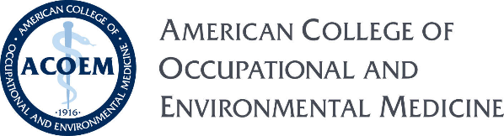
October 11, 2024
Dear Delegate,
I want to officially welcome you to the American College of Occupational & Environmental Medicine delegation, convening in Vietnam on December 1, 2024. As the Delegation Leader of ACOEM, I am honored to lead this group. My main role as the delegation leader is to represent our profession, to provide guidance in the development of professional exchange, liaison with the delegation support staff in the country and facilitate meaningful discussions on our topics of interest:
  - Vietnam’s Occupational & Environmental Medicine infrastructure
  - Approach to worker health and injury care
  - Mechanisms of worker safety and prevention
  - Tapestry of OEM within the larger Vietnamese health care system
The final schedule will outline the specific opportunities for our delegation to share and learn from our counterparts on both a professional and personal level through roundtable discussions, one-on-one interactions, and social events. This schedule will be sent approximately 30 days prior to the delegation convene date.
I look forward to learning about your background and getting to know you personally throughout our time in Vietnam. I will also be accompanying those of you who have elected the Cambodia extension after our time in Vietnam. Most of you, I am sure know me because of either my leadership positions or as a CME course presenter of ACOEM. I was also the ACOEM Delegation last year for the Cultural Vista program trip to Cuba. That experience was extraordinary, and I am thus lucky to be looking forward to duplicating that quality engagement with this trip.
I look forward to joining you and other ACOEM members and their guests as we represent the US OEM field on this professional exchange.
Sincerely,
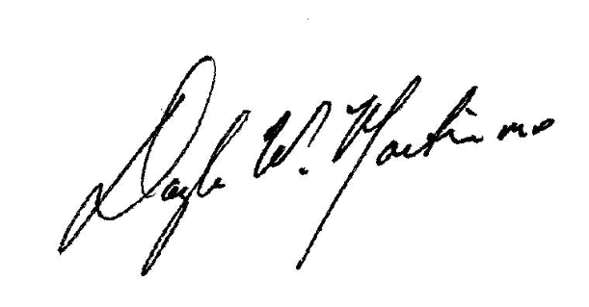
Douglas W Martin MD FACOEM FAAFP FIAIME
Past President and Delegation Leader - ACOEM

