

Optional Cultural Extension

Cienfuegos and Trinidad, Cuba


$1550 per person
(The Program fee is based on double occupancy; a single supplement of $300 is charged for those wishing a single room.)

Optional Cultural Extension Registration Form

Day 1: (Departure day for the main professional program)
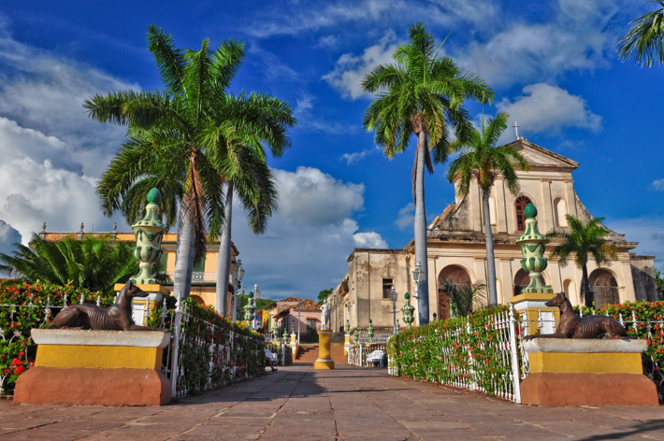
This morning drive down the coast from Havana, south to Cienfuegos. Cienfuegos is located in the heart of the Cuba’s sugar cane, coffee, and tobacco, farming region. As a port city, Cienfuegos has been a melting pot of architecture and culture. However, the French colonial influences are the most dramatic. After lunch, take a walking tour of Cienfuegos including Art studios, the main square, and the Tomás Terry Theater. A mixture of French, Spanish and Cuban architecture, followed by a visit to the Danza Espiral company. The Danza Espiral Company is a community project focused on child development.

Check into the Melia Trinidad Peninsula Hotel, a modern 5-star hotel alongside the sea and with spectacular views of the Caribbean. The property is an all-inclusive boasting 15 restaurants and bars, which will satisfy any palette.

Overnight: Melia Trinidad Peninsula Hotel

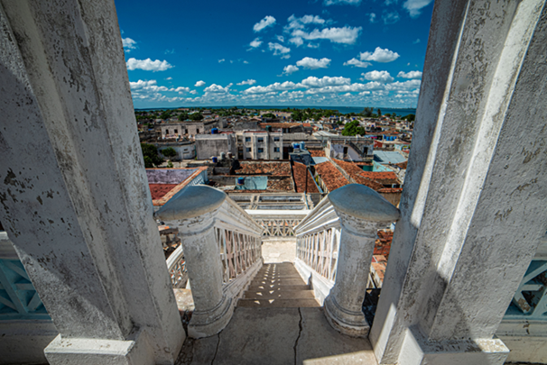
Day 2:This morning, following breakfast at the hotel, enjoy the coastal sights as you head down the coast to the colonial town of Trinidad. Trinidad has been a UNESCO World Heritage Site since 1988. The center of the sugar trade during the 18th and 19th centuries, Trinidad is one of the best-preserved cities in the Caribbean .

Walk the cobblestone streets on your guided tour of the city, including a stop for a Canchanchara, for a traditional Cuba cocktail. Created when the sugar industry was booming in the region, it is comprised of aguardiente de caña (the first distillation of sugar cane), honey, limón crillo (also known as Mexican lime or key lime) and water.

Visit the local artisan workshops to see the local woodcarvers and visit with the locals at the Casa del Alfarero community project. The enjoy Lunch on your own and free time to explore Trinidad

Overnight: Melia Trinidad Peninsula Hotel

Day 3: Today, continue exploring the region with your guide and time on your own to explore. Enjoy the rich culture of the agricultural region.

Overnight: Melia Trinidad Peninsula Hotel

Day 4: Depart for the United States from the International Airport "Abel Santamaría Cuadrado" of Santa Clara.

The program fee includes:
- Accommodations at the Melia Trinidad Peninsula Hotel
- Meals as listed in the itinerary
- Admission fees for included program activities
- All ground transportation
- Local English-speaking guide
- Airport Transfer

Please Note: Please hold on booking your flight until the extension is confirmed via email.

