

Kanha National Park Cultural Extension
24 Nov – 27 Nov 2024

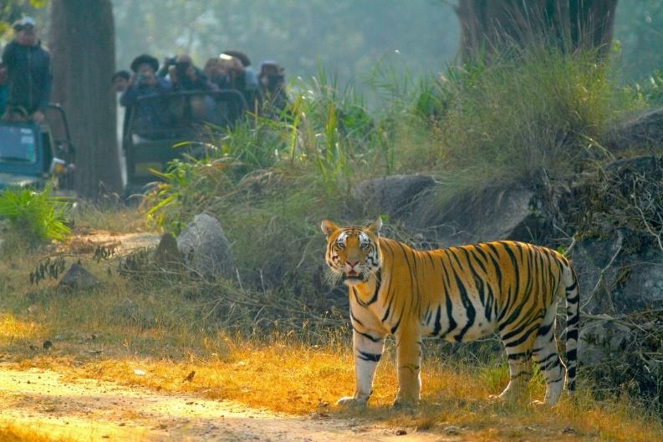
Day 1 (Sun)
Today fly to Raipur. Upon arrival, enjoy the beautiful landscapes of Madhya Pradesh on the drive to Kanha National Park. Kanha National Park is one of the most renowned tiger reserves in India and is famous for its rich biodiversity and stunning natural beauty. It served as the inspiration for Rudyard Kipling’s “The Jungle Book,” featuring a lush forest setting.
Meals: Breakfast, Dinner

Day 2 (Mon) Kanha National Park
Get ready for an exhilarating journey at sunrise with a morning safari in Kanha National Park! As the first rays of sunlight pierce through the dense canopy, the open-air jeep delves into the heart of the park. Accompanied by a knowledgeable naturalist, the safari provides valuable insights into the park’s ecosystem, pointing out different species of flora and fauna along the way. This prime-time adventure is perfect for spotting elusive predators such as tigers and leopards. With a bit of luck, visitors may witness these majestic creatures in their natural habitat, while other park inhabitants like spotted deer, langurs, and wild boars gracefully graze in the meadows or meander through the dense foliage.
The afternoon is yours to unwind, soak in the atmosphere, and revel in the thrilling surroundings!
Meals: Breakfast, Lunch, Dinner

Day 3 (Tue) Kanha National Park
Morning, walk to the nearby village. Be a guest in a tribal home; see cow dung patty cakes being made for fuel wood; observe the neatness and beauty of the kitchen gardens and home- grown produce being dried in the sun; watch the women work in the fields; paint intricate designs on their walls and floors; visit the temple and understand the harmony of their lives with nature.
After a leisurely lunch break, the afternoon jeep safari at Kanha National Park unfolds with a transformative shift in the landscape. In the cooler temperatures, wildlife activity peaks as the jeep navigates through diverse ecosystems. Witness a myriad of wildlife, including various deer, monkeys, and colorful birds, while the naturalist shares anecdotes about the park’s history and the importance of conservation. The highlight may include encounters with large herbivores like the Indian gaur and the barasingha. Kanha’s diverse topography ensures a captivating journey, revealing new aspects of its rich biodiversity at every turn.
Meals: Breakfast, Lunch, Dinner

Day 4 (Wed) Kanha – Raipur
Today, drive to the Raipur airport to connect your onward flight.

Cost Includes
- All arrival and departure transfers
- Entrance Fee
- meals as specified
- Internal flights (Hyderabad – Raipur – Delhi/Mumbai)

Cost does not include
- Gratuities, personal expenses

Accommodations:
The delegation will stay at either Singinawa Jungle Lodge or Bagh Vilas, both located adjoining the Kanha Tiger reserve and feature luxury bungalows and cottages, with large bedrooms, private verandas, and en-suite bathrooms.

Note: - Gratuities are not included in this package. Suggested Gratuities–
- Driver – Total USD 50
- Naturalist – USD 15 Per Safari
- Lodge Staff (Housekeeping/ Bell Boys) – USD 15 per person

