
Before you Depart for Cuba

Print a copy of the Travel Essentials Information page and carry with your travel documents. This document has emergency contact information, hotel contact information, and arrival information.

Plan to carry these documents in an accessible place for check-in:
- A Valid US Passport
- Electronic Ticket confirmation number
- PDF of your D’Viajeros Form-see below- QR code is required.
Mandatory online D’Viajeros form (Advance Traveler Information Form)- available beginning 7 days prior to your arrival in Cuba.
Please Note: You will need your Visa Number to complete this form.

The form can be accessed at https://dviajeros.mitrans.gob.cu/inicio.
The D’VIAJEROS Form must be completed no earlier than 7 days prior to arrival in Havana.
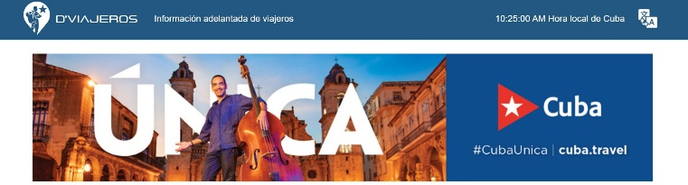
Translation Icon, click to select language

Take note of the information required, most is not required

Page 1: Personal Data:

Hint: Second Name-middle name

Hint: Second Sur Name- if two last names

Hint: The United States is listed as USA

Page 2: Migratory Information

Hint: Travel Reason- select Tourism

Hint: Electronic Visa Number- 10-character alpha code provided via email.

Page 3: Sanitary Information

Hint: Place of Accommodation- Hotel

Hint: Name of Hotel: Grand Aston La Habana

Hint: Health information is not required.

Page 4: Customs Information

Hint: Unaccompanied Baggage- NO

Hint: If you are not carrying more than $5000USD, please scroll to the end of the page and select NO- nothing to declare

IMPORTANT: Following submission of the form, you will receive a PDF of the form with a QR code. Please PRINT the PDF with the QR code and include with your travel documents. You will also be sent confirmation of the completion of the form via email, if you provided your email when completing the form.
The QR code will be scanned by the departure airlines in Miami and by immigration/customs authorities upon arrival in Havana.

Quick Tips on Travel In Cuba

Money. Bring Cash- US credit cards are not accepted at most places and the ATMs will not accept US credit cards. ATMs, when available are unreliable.
- The Hotel Currency Exchange desk is the easiest way to change money. Going to a bank in Havana can be a long process.
- Unless you plan on purchasing expensive artwork, you should not need more than $500-$600 for your travel. Only 1-2 meals are not included in the program
- Food is relatively inexpensive. Cuban spirits are reasonable. Imported spirits are very expensive… enjoy the local products.

DO NOT Drink the water. Bottled water will be provided each day on the bus and is available in the hotel.
- Brush your teeth with bottled water
- Only have ice in beverages at the group restaurants or delegation hotel- always ask if unsure.
- Do not open your mouth while in the shower

On your own nights. Please do enjoy venturing out and exploring Havana.
- Your Guide/Delegation Manager can assist with dining suggestions.
- Taxis and small Coco cabs are safe. Ask the fare before you depart
- Carry a piece of paper with the hotel address and phone number in Spanish for easy communication- the hotel front desk can help.
- If wandering in Old Havana, and you get lost, take a horse-drawn carriage back to your starting point. The drivers know the way, it is inexpensive and a fun experience
- Food in Cuba and the selections available are dependent on the available resources.
Tipping. When out on your own, Tipping is expected and an important income for many service people
- Hotel maid service: $1-2 per day
- Taxi/Coco driver: $2-4 (unless a long drive)
- Restaurants/Paladars/Bars: 10% of the bill or $1-2 per person
- Musicians: $1-2 per person
- Public restroom attendants: $.25-$50
- Tips can be paid in US Currency
- Tips for your program are included in the program and will be distributed by your Delegation Leader with the exception of your Delegation Manager and Guest Program Guide.
- The Tip for your Delegation Manager and Guest Program Guide are NOT included in the program fee. This is because this person is key to the success of the program and will work hard to ensure a productive exchange and enjoyable experience for the guests.
- For the Delegation Manager and Guest Guide, the suggested amount for tipping will not exceed $50. Your Delegation leader will “pass the hat” on the final day and present to these two individuals on the last evening. If you wish to personally add something to this tip, it is always appreciated.
- Tips that are included in your program (distributed by your leader): bus drivers, hotel bell staff, restaurants, and local site guides.
Purchasing Artwork. Cuba has many fine artists and if you should purchase a piece of art from a gallery, please keep your receipt as you may be required to show it at departure.

