Cultural Extension to Siem Reap and Angkor Wat

December 7 - 9, 2024

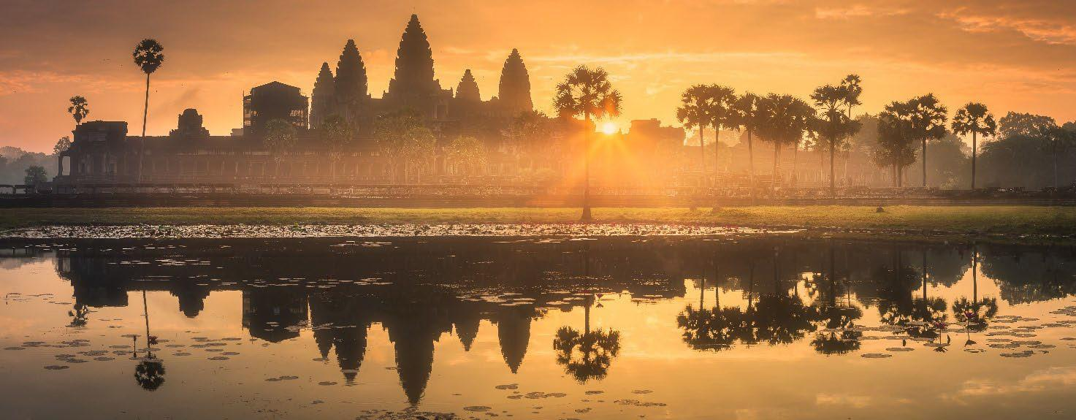

DETAILED ITINERARY

Day 1 (Sat) Dec 7, 2024 Fly Ho Chi Minh City – Siem Reap, CAMBODIA
Cambodia Angkor Air K6 825 at 1200 / 1315 hrs
Transfer from the Ho Chi Minh City hotel to the airport to connect your flight to Siem Reap. Siem Reap is the base for exploring the fabled temples of Angkor, the ancient capital of the Khmer Empire.
Upon arrival at Siem Reap International airport, you will be welcomed by your local English-speaking guide and transferred to the Sokha Palace Siem Reap Hotel and Resort. The Sokha Palace is the perfect combination of luxury and tranquility set amidst lush tropical gardens. The setting offers the authenticity of traditional Cambodian design infused with fresh modern features and 5-star facilities.

***Lunch is by individual arrangement (own expense).

Afternoon, visit the spectacular temples at the ancient city of Angkor Thom, the last capital of the Great Khmer Empire under the reign of Jayavarman VII. This city is surrounded by an 8 m high wall, drawing a perfect square. Enter the city through the ancient South Gate, an impressive stone gate carved with Elephants and four giant faces. On each side of the entrance path lies a row of 54 gods or demons, holding the sacred Naga snake welcome you.

From here, continue to Bayon Temple in the exact center of the city. This 12th century masterpiece is a study in grandeur and is well-known for its 54 towers with enigmatic faces representing the 54 provinces of the Great Khmer Empire. The Terrace of the Elephants and the Terrace of the Leper King are also must-visits as they are both known for their intricate bas-reliefs.
Overnight: Sokha Palace Hotel and Resort
Meals: Dinner

Day 2 (Sun) Dec 8, 2024 Siem Reap
Wake up in the early hours of the morning (around 4:30am) to witness the mesmerizing sunrise at the iconic Angkor Wat temple, an enchanting experience that allows you to marvel at the temple's grandeur in a magical light. As the sun ascends, its golden rays illuminate the intricate carvings and majestic spires of Angkor Wat. The tranquil pools surrounding the temple reflect this awe-inspiring sight, creating a serene atmosphere. This momentous occasion connects you to Cambodia's rich cultural heritage and evokes a deep sense of wonder. It's a time when history and nature converge, enabling you to appreciate the temple's architectural magnificence and spiritual significance in a captivating way.

Once the sun is up, go inside Angkor Wat for a guided tour. Learn about the history of this 12th- century monument and how it was constructed. Get up close and see depictions of Hindu mythology and famous battles intricately carved into the walls. Explore chambers filled with depictions of Apsara dancers, celestial beings of Hindu mythology.

Return to the hotel for breakfast.

Late this morning (around 10pm) head out to the Angkor Archaeological Park, to explore the temples. First visit Preah Khan, originally known as “the city of victorious royal fortune,” and now named after The Sacred Sword that some belief was once housed here. Built-in the late-12th century in honor of the great King Jayavarman VII’s father, this massive temple complex originally had a population of 97,840 in its service. Less frequently visited than its counterpart Ta Prohm (which was built for the king’s mother), Preah Khan is similar in design but is larger and more complex, featuring numerous unique structures and carvings. Enter from the east with the early morning light to your back and enjoy the sounds of exotic wildlife that now make the forested compound their home. Venture into the crumbling corridors of the labyrinthian complex in search of hidden features: while Ta Prohm was once the setting of the Angelina Jolie film, Preah Khan offers more of a “Tomb Raider” experience for those willing to explore.

***Lunch is by individual arrangement (own expense).

Later visit Satcha, a local artisans center, combining traditional knowledge with contemporary designs to showcase Cambodian handicrafts passed down through generations. The local artisans share their crafts and skills from natural wellness and food products to traditional arts. Take a walk through the serene, natural gardens and watch the artists carve stone, and wood, weave baskets, paint, and more while your guide explains some specific traits about each field of work.
Overnight: Sokha Palace Hotel and Resort
Meals: Breakfast, Dinner

Day 3 (Mon) Dec 9, 2024 Siem Reap – Departure
You will have free time until the transfer to Siem Reap International Airport for the departure flight.
Meals: Breakfast

TRAVEL MANAGER
Ms. Tasneem Bhavnagarwala +91 982 037 6472 (available via call and WhatsApp)

24-HOUR EMERGENCY CONTACT
Mr. Manoj Abraham +91 98110 93859 (available via call and WhatsApp)

HOTEL DETAILS
Sokha Palace Hotel and Resort, Siem Reap (2 nights)
Address: Street 60, Krong Siem Reap, Cambodia
Phone: +855 96 616 1789

