

Havana, Cuba

Accompanying Guest Program

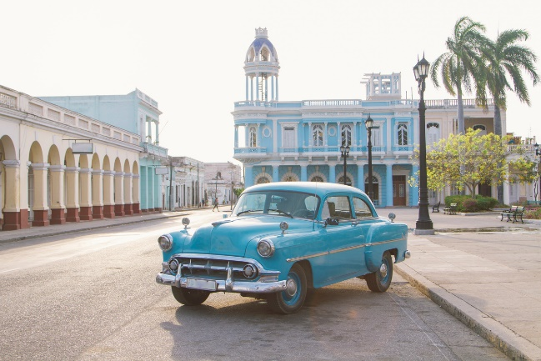
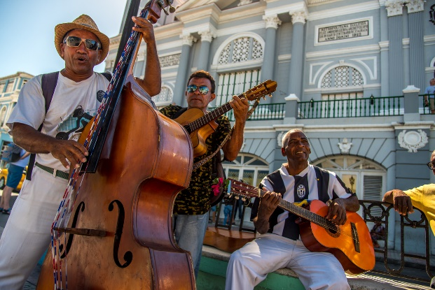
Guests will accompany Professionals on all non-professional Program activities. Guests will meet with the professional delegates for all dinners, and lunches as appropriate. Guests will have a full schedule of people to people and cultural orientation activities. Below is a list of planned sites. Please note this list of activities may change based on the parallel professional program schedule and seasonal closures.

- The José Fuster community project
- A community guitar project "Vocal Clave de Sol"
- National Capitol Building
- Ernest Hemingway Museum at Finca Vigia
- Cuban Institute of Friendship with the Peoples
- Visit the National Botanical Garden
- Old Havana, a UNESCO World Heritage Site
- Performance by Habana Compas Dance
- Havana’s National Museum of Fine Arts

If you have not already enrolled. Please use the application form for the delegation you will be accompanying.

