

Optional Cultural Extension to Rio de Janeiro

Rio de Janeiro- known as the “Cidade Maravilhosa” (The Marvelous City) is nestled between lush-green mountains and crystal-clear seas. Rio is known for its rhythm and excitement, as well as the breathtaking scenery.

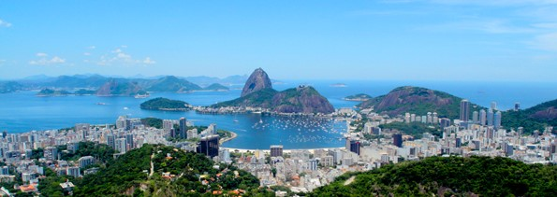

Extension Program Fee:
$1050 (based on double occupancy)- including flight from Sao Paulo to Rio De Janeiro
For those choosing a single room the supplement is $150

Optional Cultural Extension Enrollment Form

Schedule of Activities

Day 1- Thursday
SAO PAULO - RIO DE JANEIRO
Depart from hotel to Guarulhos international airport (GRU) to catch your domestic flight to Rio De Janeiro. Transfer time is about 1h 30 minute and may last longer depending on the traffic conditions.

Arrival in Rio Airport and transfer to hotel
Our ground partner guide will meet you outside the restricted luggage claim area, for your private transfer to the hotel. En route, your guide will share curiosities, stories and give some general recommendations about Rio de Janeiro.
(Standard check-in time is at 15:00)

Rio by night - Rio Scenarium with dinner
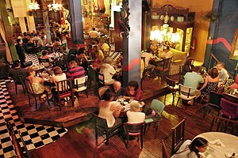
There is no other place in Rio that embodies the happiness of Brazilian people more than the nightlife scene in the neighborhood of Lapa. Once the sun goes down, this normally quiet neighborhood turns into a bustling and vibrant area full of restaurants, nightclubs, and bars. The streets fill with Cariocas and gringos alike, who flock to this Rio nightlife Mecca with one thing in mind……fun!! From traditional northeastern forró to Rio’s own samba, to reggae from Bahia, visitors will enjoy the best that the Rio music scene has to offer.
On the Rio Nightlife Tour, we will take you right to the heart of the action where our local guides will accompany you to one of the best clubs in Lapa, Rio Scenarium, for dinner. This unusual bar, a mix between an antique shop and an auction room, is where the locals come to listen to traditional Brazilian jazz and samba.
Meals: D
Day 2- Friday
RIO DE JANEIRO

Corcovado and Sugar Loaf
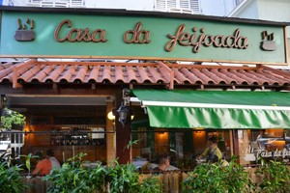
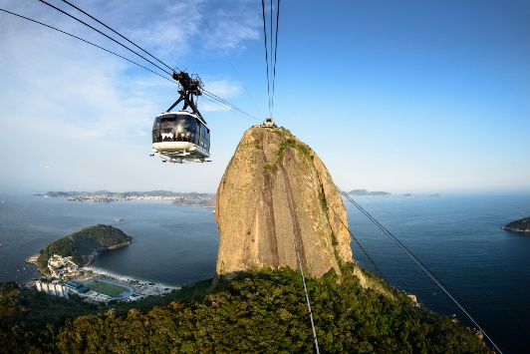
Depart from the hotel after breakfast to visit the city's most famous landmarks and see the natural beauty of Rio de Janeiro from above. After a scenic drive along Rodrigo de Freitas Lagoon, passengers arrive at the bottom of Corcovado Hill. Embark on a comfortable train that ascends the mountain, where the statue of Christ the Redeemer is located 2,300 ft above sea level. The Christ statue, known as the “wonder of Rio,” was elected one of the 7 "New Wonders of the World." Upon arrival at the top, guests can use the panoramic elevators or escalators to arrive at the foot of the statute. Passengers can enjoy a panoramic view of Rio de Janeiro and discover why it is called the "Marvelous City." Afterward, descend the mountain and stop for a delicious lunch.
Over a million tourists each year visit the world-famous ‘Pão de Açúcar’ (Sugar Loaf Mountain), which has become an iconic symbol of Rio de Janeiro. Rising up from a small peninsula at the entrance of Guanabara Bay, its name refers to its resemblance to the traditional shape of a concentrated, refined sugar loaf. The journey to the top is made in glass cable cars. The first cable car takes passengers to the top of Urca Hill, which rises 215 meters above sea level and offers spectacular views of the entire bay and its surrounding islands. From Urca Hill, passengers continue in a second cable car to the top of Sugar Loaf, which rises 395 meters above sea level and offers a 360-degree view of the entire city, including Botafogo and Copacabana Beaches, Corcovado Mountain, and downtown Rio de Janeiro.
Lunch at Casa da Feijoada.
Feijoada Considered one of Rio’s most famous restaurants for feijoada, the Casa da Feijoada restaurant specializes in Brazilian food. Unlike many other places, it offers our national dish every day of the week. Feijoada is a bean stew with a variety of different meats, usually served with rice, collard greens, and sliced oranges, as well as other side dishes. Casa da Feijoada is in the trendy Ipanema neighborhood.
Meals: B,L

Day 3- Saturday

Departure transfer from hotel to Rio de Janeiro/Galeão–Antonio Carlos Jobim International Airport International Airport (GIG).

You will be taken to the airport accompanied by your guide. At the terminal, your guide will show you where to go and assist with check-in procedures.
Meals: B

Cancellation is subject to the Cancellation Policy in the Terms and Conditions of Participation.
Extension Program includes:
- Flight from Sao Paulo to Rio De Janeiro (departure point following the program)
- Airport Transfers
- Support 24/7 during the program
- Meals as outlined in the program
- Entrance fees for all activities listed in the preliminary schedule of activities
- Air-conditioned Motor Coach
- Bilingual guide throughout the program
- Water bottle included in the buses during transportation.
- 2 nights’ accommodation at the Windsor Copa Hotel
- Tips for services including driver.
NOT INCLUDED:
- Personal expenses and incidentals
- Airport porterage
- Hotel room tax- approximately $2 per night (subject to change)*
*Hotel Room Tax is neither a fee nor a tax. It is a contribution from the visitor to support the for the improvement of the city, such as its structure, maintaining its tourist attractions, and protecting the environment. The amount changes frequently and is paid at the time of departure from the hotel.

