

Dear LRA Community,

As the 2024-2025 President of the Literacy Research Association (LRA), I am honored to have been selected as leader of the LRA Delegation to Brazil. I invite you to join me and other literacy and education academics and professionals to participate in this important international exchange.

Brazil's Ministry of Education announced the National Child Literacy Commitment, in mid-2023, aiming to ensure children learn to read and write by the age of seven.
Through this program over three billion dollars is being invested in teacher education, infrastructure, assessment, and curriculum management, requiring extensive collaboration between federal, state, and municipal governments. Now, only two years into the National Child Literacy Commitment initiative the project has shown significant progress.

While celebrating the positive strides in literacy and reading education in Brazil, this spotlight has also revealed the ever-growing efforts by Brazilian authorities to censor books in public schools, which do not align with their philosophies or support personal beliefs. Parents and educators fear censorship will have a profound impact on students’ education and personal development, by narrowing the scope of education, limiting critical thinking opportunities and reducing the overall quality of literacy education.

So, while student literacy rates increase, what students read is becoming more and more controlled. Censorship of literature in schools, particularly targeting works that explore themes of race, gender, and LGBTQ+ identities, has drawn backlash from educators, parents, and free speech advocates. There was public outcry over the banning of Jeferson Tenório's novel "O Avesso da Pele." Told from the perspective of Pedro the novel paints a vivid portrait of how Black bodies are marked in Brazilian society, especially in terms of violence, invisibility, and exclusion. It paints a picture of structural racism and police violence.

Our delegation will meet with education program officials, academics and educators to learn about the advances in literacy through the National Child Literacy Commitment and will discuss the impacts and response to book banning/censorship in Brazil.

Our delegation will convene in Sao Paulo, Brazil, on October 25, 2025, and concluding on October 30, 2025. The initial program outline and planned topics of discussion are listed on the Delegation Preliminary Schedule of Activities, and additional information on the program is available on the LRA Brazil Delegation Communication Site.

This delegation has been developed In conjunction with the Citizen Ambassador Program, a program of Cultural Vistas, to foster one-on-one dialogue with our overseas counterparts and develop lasting professional connections for future collaboration.

I believe you would contribute valued expertise to the team while gaining both personally and professionally from the experience. I hope that you can join us.

As Cultural Vistas’s Citizen Ambassador programs are private-citizen initiatives, delegates are responsible for their own program costs. The estimated cost per delegate is $4750. This includes ground transportation associated with the program, all professional and cultural activities, as specified in the preliminary schedule of activities, accommodations, most meals, and essentially all other costs associated with participation. As delegates will be arriving from across the United States and internationally, international airfare is not included.

For many professionals, this program may qualify as a continuing education expense and may be tax deductible as a qualified expense. Please contact your personal tax advisor for your specific tax implications.

I encourage you to invite a travel companion to share this unique experience with you. A parallel program focused on the culture of Brazil will be arranged for your accompanying guest while you attend the professional sessions. Activities for guests will include visits to historical and cultural sites for an opportunity to explore many aspects of the culture and customs.

An optional cultural extension will allow you to spend a few more days in Brazil, exploring the exciting city of Rio de Janeiro, before you leave behind the wonderful people and the vibrant culture found only in this unique country.

Please complete the LRA-Brazil application form to enroll on this program.

Due to the extensive planning and communication involved in coordinating a program of this nature, I ask that you respond with your intentions regarding this invitation no later than July 1, 2025. In the event that you are unable to accept this invitation, an alternate delegate candidate may be invited. You may also recommend a colleague as your alternate for the program, or as a qualified professional who would add to the professional dialog. I hope to hear from you whether you are able to join our delegation or not.

If you have questions regarding the delegation, I encourage you to contact the Citizen Ambassador Program at citizenambassador@culturalvistas.org.

I am pleased to be involved in this exciting opportunity and hope you will strongly consider participating in the delegation.

LRA-Brazil application form

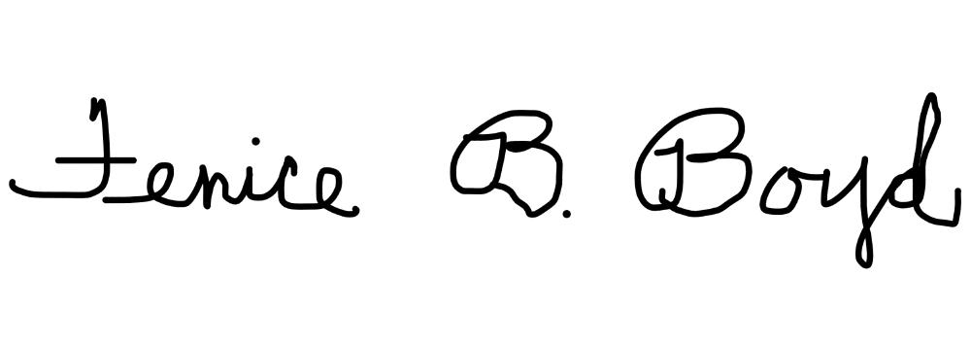
Sincerely,

Fenice B. Boyd LRA President

