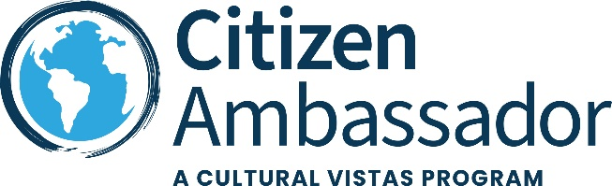
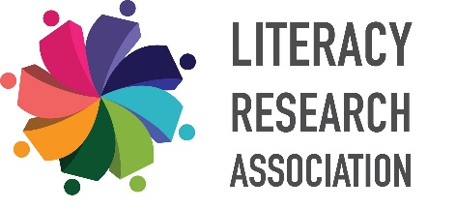

Literacy Research Association
Delegation to Brazil
October 25 – October 30, 2025

Delegation Leader: Dr. Fenice Boyd
President of the Literacy Research Association
Chair and Professor, Department of Teacher Education
College of Education, University of South Carolina

Topics of Discussion
Throughout the program as we meet with counterparts, educators, publishers, and policy advocates, we will explore the following topics of discussion. This list may change based on the composition of the delegation and the profile of the participants and upon confirmation of association meetings/visits.
- Overview of Brazil’s K-12 school curriculum, literacy development, and children’s and adolescent literature.

- Government policies and politics underlying book banning and/or censorship.
  - What are the key issues driving the movement to ban certain books?
  - What social, political, or cultural issues are fueling book bans?
  - In what ways do teachers, students, and parents/guardians differ or align in their views on book banning? Are they voicing their opinions? Are their voices heard?
  - What are the criteria used to determine whether a book is appropriate or inappropriate for a school or public library?
  - Which books and authors are most frequently banned, and what are the reasons behind these bans?
  - What impact have public protests and advocacy had on book banning efforts?
    - How effective are public opposition and grassroots movements in challenging book bans?
    - What insights can we gain from public resistance to book bans?
    - In what ways have protests and advocacy campaigns influenced public policy or public opinion on banned books?
  - In what ways have non-governmental organizations responded to or intervened in book banning efforts?

Preliminary Schedule of Activities

Day 1 (Saturday) October 25, 2025 Arrival São Paulo, Brazil
Delegates and accompanying guests will arrive in São Paulo, the capitol of Brazil, via Guarulhos International Airport, throughout the day. Upon arrival, Delegates and Accompanying Guests will be met and transferred to the delegation hotel.
São Paulo is the largest city in Brazil and the Southern Hemisphere, known for its significant economic and cultural influence. Founded in 1554 by Jesuit missionaries, it has grown into a bustling metropolis with a population of over 11 million people. The city is a major industrial and financial hub, often referred to as the "locomotive" driving Brazil's economy. It's located on a plateau of the Brazilian Highlands, about 50 km (30 miles) inland from the Atlantic Ocean
São Paulo is also famous for its diverse population, hosting the largest Arab, Italian, and Japanese diasporas in the world.
In the evening, the Delegation manager will convene the delegation for introductions, a review of the program and the delegation will be briefed on the political and cultural diversity of Brazil. Following the Orientation, the delegation will have dinner at the hotel.
The venue and time for this meeting will be determined based on arrival schedules and may be held the following morning.
Overnight: Canopy by Hilton Sao Paulo Jardins Boutique Hotel
Meals: D
Day 2 (Sunday) October 26, 2025 Cultural Introduction to Brazil
The Delegation will learn about the rich history and culture of Brazil. The full-day Cultural Enrichment Program will begin in the morning and finish with a delicious meal at one of São Paulo's many excellent restaurants. The schedule will include activities that highlight the unique character of the capital city.
The itinerary for the day is planned to include:
- Catedral da Sé: the iconic São Paulo Cathedral, located in the heart of the city. This stunning neo-Gothic structure is a must-see, with its beautiful stained-glass windows and impressive architecture.
- Theatro Municipal: A short walk from the cathedral, take in its architectural beauty and learn about its significance in São Paulo's cultural scene.
- Mercado Municipal: Head to this bustling market for lunch. Try the famous mortadella sandwich or a pastel de bacalhau (cod pastry) while enjoying the lively atmosphere.
- Pinacoteca do Estado: Visit this renowned art museum, which focuses on Brazilian art from the from the 19th century onwards.
- Avenida Paulista: stroll this famous avenue, which is often compared to New York's Fifth Avenue. It's a great way to soak up the city's vibrant street life and see some of its modern architecture.
Overnight: Canopy by Hilton Sao Paulo Jardins Boutique Hotel
Meals: BLD

Day 3 (Monday) October 27, 2025 São Paulo: Professional
Begin the day with an overview of K12 school curriculum and literacy development by the São Paulo Municipal Department of Education. Representatives will discuss key policies, initiatives to improve literacy, and collaborations with schools and NGOs to expand reading access.
Following this, meet with the Palavra Aberta Institute to examine the impact of book censorship on education, the political and ideological forces behind it, and advocacy efforts to protect access to diverse literature.
After lunch, visit Pró-Saber São Paulo, a school that integrates literacy and play-based learning for children. Engage with educators in their community-driven literacy programs, observe classroom activities, and discuss how interactive learning environments support reading development.
In the evening, delegates will have time to explore São Paulo at their own pace. The Delegation Manager will provide recommendations for dining and cultural experiences.
Overnight: Canopy by Hilton Sao Paulo Jardins Boutique Hotel
Meals: BL
Day 4 (Tuesday) October 28, 2025 Campinas, 60 miles outside of Sao Paulo: Professional
Travel to Campinas, a community outside of São Paulo, approximately 90 minutes.
Begin with a visit to the Brazilian Reading Association (Associação de Leitura do Brasil, ALB), headquartered at The State University of Campinas (Universidade Estadual de Campinas – Unicamp). Engage in discussions with ALB representatives about their ongoing research and initiatives aimed at removing barriers to literacy and cultural access across communities in Brazil.
In the afternoon, visit Colégio Culto à Ciência, a historic public secondary school. Founded in 1874, it is one of the oldest schools in Brazil and has a rich history of academic excellence and cultural significance.
Dinner will be en route back to Sao Paulo.
Overnight: Canopy by Hilton Sao Paulo Jardins Boutique Hotel
Meals: BLD
Day 5 (Wednesday) October 29, 2025 São Paulo: Professional Day
Begin the day with a meeting at Instituto Pró-Livro (IPL), a nonprofit organization dedicated to promoting literacy, reading habits, and book accessibility in Brazil. Discussions will focus on strategies to expand book access, foster a culture of reading, and leverage research from IPL’s Portraits of Reading in Brazil studies and other research initiatives to inform literacy policies and programs.
Meet with the Brazilian Book Chamber (Câmara Brasileira do Livro – CBL), a nonprofit association representing publishers, booksellers, and distributors. CBL works to promote access to books, democratize reading, and advocate for policies that strengthen Brazil’s literary market. Discussions will focus on CBL’s efforts to foster a reading culture, its collaborations with government agencies, and strategies to promote Brazilian literature nationally and internationally.
The professional exchange will conclude with a farewell dinner in the evening.
Overnight: Canopy by Hilton Sao Paulo Jardins Boutique Hotel
Meals: BLD
Day 6 (Thursday) October 30, 2025 Depart for the United States or Program
Extension
Today transfer to the airport to connect your flight back home or transfer to Rio de Janeiro for the Cultural Extension Program.

Meals: B
This Preliminary Schedule of Activities represents the initial plans for the delegation as developed in cooperation with your delegation leader, your professional counterparts, and our research team. The Final Schedule of Activities, published approximately 30 days prior to your delegation convening, will be adjusted to reflect the composition of the delegation, unique opportunities, and scheduling with your professional counterparts.

