

Optional Cultural Extension to Barcelona

Cultural Extension Program Fee: $2650 per person

Single supplement: $700

(The Program fee is based on double occupancy; a single supplement is charged for those wishing a single room.)

Optional Cultural Extension Program Enrollment Form

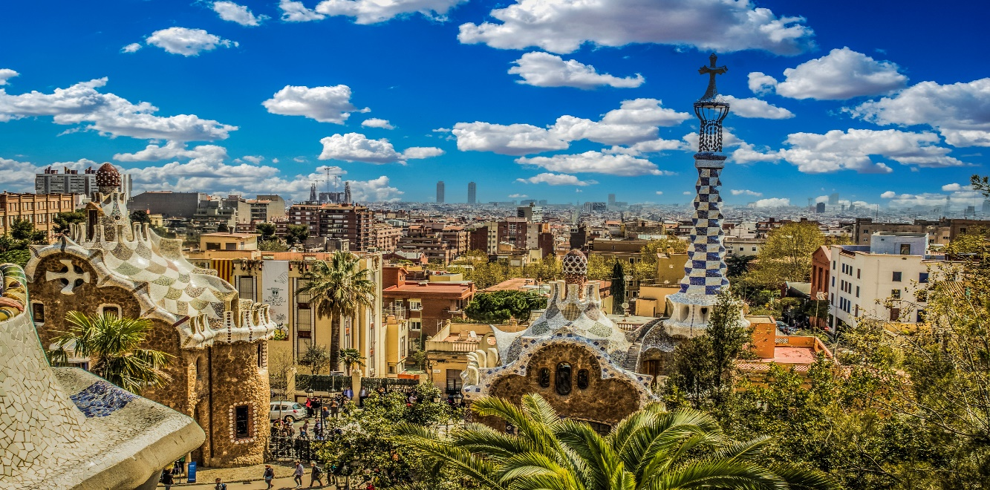

Day 1: Madrid to Barcelona
Today Transfer from Madrid via the high-speed train to Barcelona ( 3 hours) , the major industrial and commercial Mediterranean port of Spain. Barcelona is known for its beauty and artistic influences reflected in the architecture and nature scape of the city. Famous for modernist and art nouveau décor, the city exudes the Catalan Culture of the region.
Upon arrival in Barcelona, check into your hotel and strike out on foot to explore the cobblestone streets and acclimate to the unique cultural environment.

Day 2 and Day 3: Barcelona
Over the next two days, will be filled with the sites, sounds, smells, and tastes of Barcelona. A few of the highlights of these two days include:
- Visit Sagrada Familia and enjoy exploring this icon of Barcelona. The Sagrada Familia church is considered to be the best example of Modernist architecture designed by the legendary architect Antoni Gaudi.
- Take in the impressive structure and the art nouveau architecture of the neighborhood known as the Gothic Quarter and see many of the remnants of the Roman village that is not the Gothic Quarter.
- Discover this historic work-in-progress with construction continuing to this day ide the recently refurbished Montjuïc Cable Car for panoramic views of the city.
- Walk the La Rambla, the heartbeat of Barcelona, a bustling boulevard that captures the essence of the city’s energy and diversity.
Explore many of the whimsical creations of Antoni Gaudí, a Catalan architect and designer, known for his unique Catalan Modernism design.
- Casa Batlló, known for its colorful facade and imaginative design. And t
- Casa Amatller, a stunning Art Nouveau architecture example.
- Casa Milà (La Pedrera): with its amazing wavey stone facade.
- Park Güell: filled with colorful mosaics, sculptures, and panoramic views of the

Day 4: Departure
Depart from Josep Tarradellas Barcelona International Airport ( BCN) for your return to the United States.
The program fee includes:
- Transfer from the final delegation hotel in Madrid to Barcelona- high speed train with escort
- 3 nights, Accommodations at the B-Hotel ( B for Barcelona)
- Meals: breakfast daily at the hotel, two Lunches, one dinner
- Admission fees for included program activities
- All ground transportation
- Local English-speaking guide

Please Note: Please hold on booking your flight until the extension is confirmed via email.

