

Optional Cultural Extension to Kathmandu, Nepal
(3 Nights / 4 Days)

Extension Program Fee:
$1500 (based on double occupancy)- including round trip flights from Delhi-Katmandu-Delhi
For those choosing a single room the supplement is $395

Optional Cultural Extension Enrollment Form

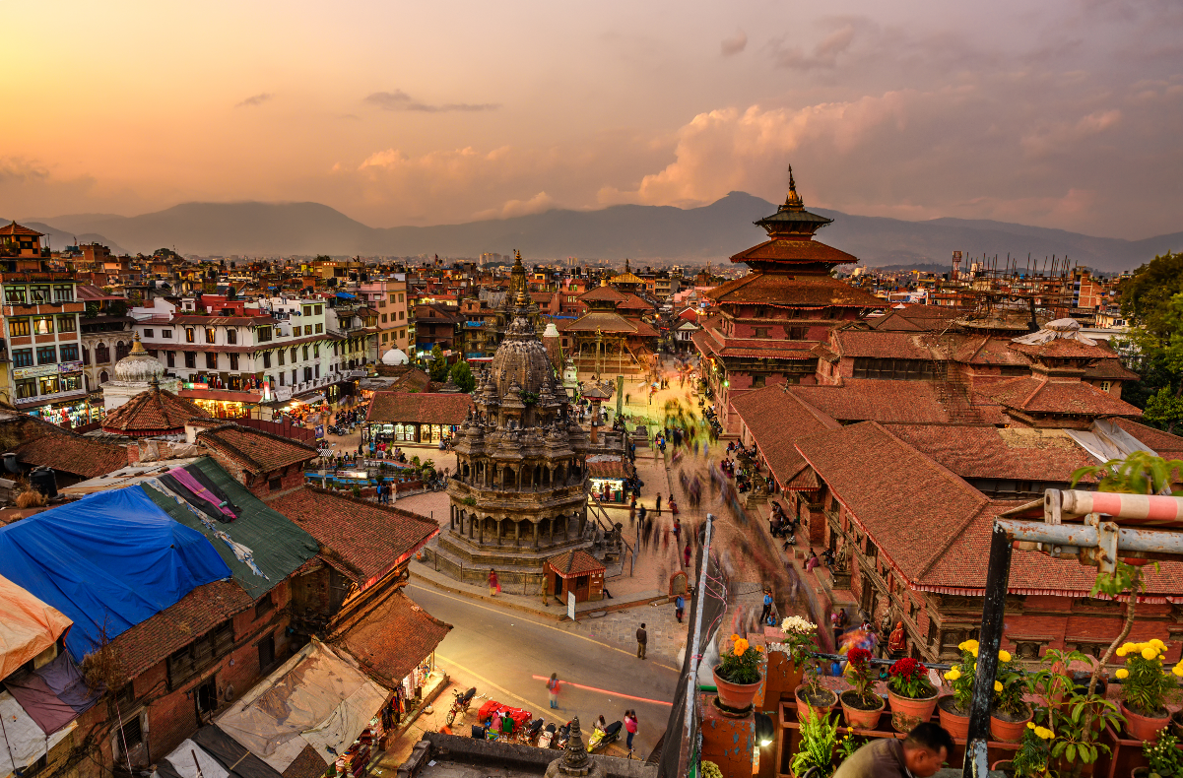

Day 1 Fly Delhi – Kathmandu, NEPAL
This morning, transfer by private vehicle to the airport for your flight to Kathmandu. Arriving Tribhuvan International Airport (TIA). (flight Included)

In the quiet hum of Kathmandu’s ancient streets, where time seems to blend the pulse of tradition with the rush of modern life, begins a journey into the heart of Nepal. From the spiritual grandeur of the Pashupatinath Temple to the intricate wood carvings of Bhaktapur Durbar Square, each stop unveils another layer of a culture that has evolved over millennia, rooted in its Hindu and Buddhist heritage. Nepal’s beauty can be experienced through its people, whose lives unfold in their deeply spiritual traditions and way of life, as if in harmony with the rhythm of prayer flags fluttering in the Himalayan wind and ancient dances under the starlit skies.

Upon arrival, a representative will meet and transfer to hotel. After check-in and a short orientation, enjoy time at leisure to relax and absorb the tranquil setting.

In the evening enjoy a delicious dinner featuring local cuisine

Day 2 Kathmandu
After breakfast, begin your day with a visit to Pashupatinath Temple, one of the holiest Hindu temples in Nepal, dedicated to Lord Shiva. Located along the banks of the Bagmati River, Pashupatinath is a UNESCO World Heritage site and an important pilgrimage site for Hindus around the world.

Next, we head to Boudhanath Stupa, also a UNESCO World Heritage site and one of the largest and most important Tibetan Buddhist stupas in Nepal. Standing at 36 meters tall, the stupa is a focal point for Tibetan Buddhism, with a massive mandala at its base. You can observe Buddhist monks and pilgrims from Tibet and Nepal performing their daily rituals, creating an ambiance of devotion and peace.

In the afternoon, we drive to Bhaktapur Durbar Square, a medieval city that offers a step back in time with its well-preserved Newar architecture, rich history, and vibrant culture. As you stroll through the square, you'll be captivated by its intricate wood carvings, towering temples, and decorative statues. The square is home to Vatsala Temple, Ugrachandi and Bhairab Temple, and the majestic 55-Window Palace, which reflects the grandeur of the Malla dynasty. Bhaktapur is also famous for its Pottery Square, where you can witness traditional potters skillfully shaping clay into bowls, pots, and other items using ancient techniques passed down through generations.

Day 3 Kathmandu
After breakfast, we begin the day with a visit to Swayambhunath Stupa (also known as the Monkey Temple), perched atop a hill offering a panoramic view of Kathmandu Valley. This UNESCO-listed site is one of the most important religious monuments in Nepal, offering a serene atmosphere and the chance to observe the daily rituals of Buddhists.

Next, we visit Kathmandu Durbar Square, the ancient royal palace complex that once served as the residence of the Malla kings. This UNESCO World Heritage site is a stunning example of Nepal’s architectural heritage, featuring an impressive collection of temples, shrines, and historic courtyards. Among the highlights is the Hanuman Dhoka Palace, with its intricately carved wooden windows and the Kumari Ghar, the residence of the living goddess, Kumari. The square also houses several monumental temples, including the Kasthamandap and Vishnu Temple, which showcase traditional Newar craftsmanship and intricate stone carvings.

In the afternoon, we visit Patan Durbar Square, located in the heart of Patan, a city renowned for its rich Newari architecture and religious monuments. The square is a masterpiece of traditional craftsmanship, home to beautiful temples, pavilions, and statues, including the towering Mahabouddha Temple and the elegant Krishna Mandir. The square's centerpiece is the Patan Museum, housed in a former palace. The museum is dedicated to preserving and displaying the rich cultural and artistic heritage of the Kathmandu Valley, featuring an impressive collection of traditional art, sculptures, and religious relics.

Day 4 Departure
Today transferred to airport for the return flight to Indira Gandhi International Airport, New Delhi, and connecting flights home. (flight included)

Extension Program includes:
- Round trip flight Delhi-Kathmandu-Delhi
- Airport Transfers
- Support 24/7 during the program
- Entrance fees for all activities listed in the preliminary schedule of activities
- Air-conditioned Motor Coach
- Bilingual guide throughout the program
- Water bottle included in the buses during transportation.
- Tips for services including driver.
NOT INCLUDED:
- Program Guide
- Personal expenses and incidentals
- Airport porterage

Cancellation is subject to the Cancellation Policy in the Terms and Conditions of Participation.

