Norwegian Adventure

Oslo, Bergen & Fjords
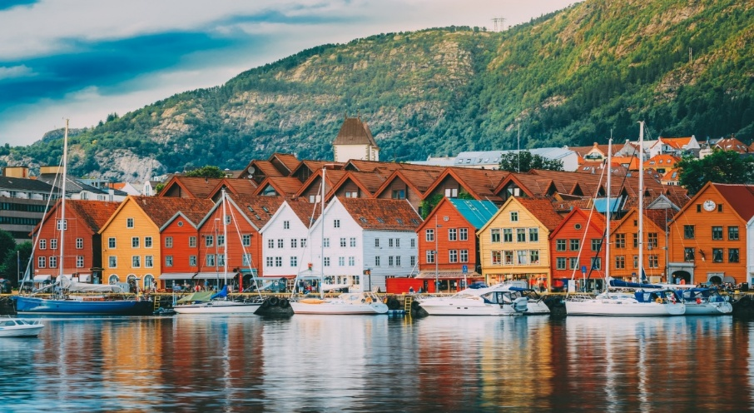
Discover the breathtaking beauty of Norway’s fjords and experience the best of the country’s natural wonders and cultural highlights. From cosmopolitan Oslo to coastal Bergen and deep into the majestic fjords, this three-day adventure offers a captivating blend of history, scenery, and unforgettable experiences.

Cultural Extension Program Cost:

$3885 USD, Single supplement $1150

(includes the one-way flight from Reykjavik to Oslo)

Cultural Extension Enrollment Form

Day 1: Arrival in Oslo
Fly from Reykjavik to Oslo, Norway’s vibrant capital. Upon arrival, enjoy a guided city tour including highlights such as the Royal Palace, Vigeland Sculpture Park, the Oslo Opera House, The Nobel Peace Center, The University of Oslo Museum of Natural History and the Akershus Fortress.
Overnight: Grand Hotel Oslo

Day 2: Scenic Train Ride – Oslo to Bergen
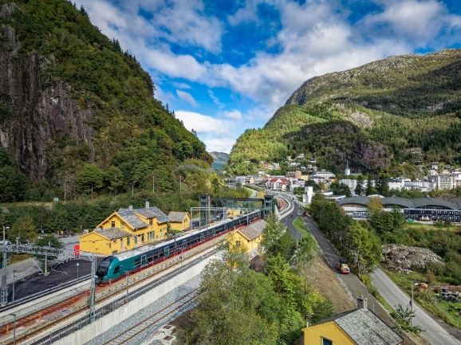
Embark on one of the world’s most spectacular rail journeys: the Oslo to Bergen train. This route offers panoramic views of Norway’s diverse landscapes, from serene lakes and alpine forests to dramatic mountain plateaus and cascading waterfalls.
Arrive in Bergen around 4 PM and enjoy a guided walk through this historic city. Visit Bryggen, the Hanseatic Wharf, a UNESCO World Heritage Site known for its colorful wooden buildings dating back to the Hanseatic League.
Overnight: Hotel Opus 16

Day 3: Bergen and Fjords Cruise
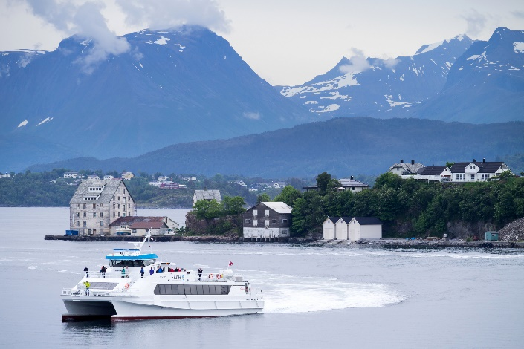
Spend the day immersed in Bergen, often called the Gateway to the Fjords. This charming coastal city is famed for its rich history, colorful architecture, and stunning natural surroundings.
In the morning, cruise the scenic fjords. Sail past towering cliffs, quaint villages, and dramatic waterfalls as you experience the serene beauty of Norway’s legendary waterways.
After the cruise, enjoy lunch at the Bergen Fish Market—an open-air harbor market full of fresh seafood, local delicacies, and vibrant energy. Try Norwegian salmon, king crab, or traditional fish cakes.
In the afternoon, travel to the top of Mount Floyen by funicular railway, a cable railway that runs up the steep slope, connecting central Bergen with Mount Floyen. And offers one of the most photographed views of the city. Later visit the KODE Art Museums, one of Scandinavia’s largest collections of art and design.
Overnight: Hotel Opus 16

Day 4: Departure
Depart from Bergen International Airport. Additional hotel night accommodations and private airport transfers can be arranged for those wishing to extend their time in Norway.

Cancellation is subject to the Cancellation Policy in the Terms and Conditions of Participation.
Extension Program includes:
- Flight from Reykjavik to Oslo (departure point following the program)
- Airport Transfers
- Train fare Oslo to Bergen
- Support 24/7 during the program
- Entrance fees/ cruise fare- for all activities listed in the preliminary schedule of activities
- Motor Coach
- Bilingual guide throughout the program
- Water bottle included in the buses during transportation.
- Tips for services, excluding Extension Guide or Delegation Manager.
NOT INCLUDED:
- Personal expenses and incidentals
- Airport porterage

