Certified Registered Nurse Anesthetists (CRNA)

Delegation to Spain

Optional Cultural Extension to Barcelona
November 14-17, 2025
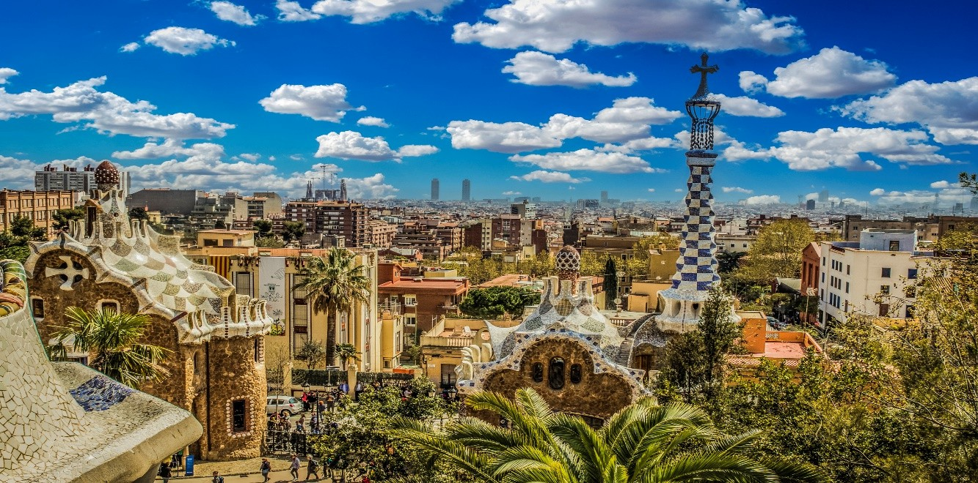

DETAILED ITINERARY

Friday, November 14, 2025 Train Madrid to Barcelona at 9:27
At 8:15 AM, transfer to Atocha Station and board the high-speed AVE train in 1st class for a three-hour journey to Barcelona, Spain’s major industrial and commercial hub on the Mediterranean. The city is renowned for its stunning architecture, artistic heritage, and vibrant Catalan culture, with modernist and art nouveau influences shaping its urban landscape.
Upon arrival in Barcelona, transfer to your hotel for check-in, followed by a group lunch in the city centre. Take some time to relax before beginning the afternoon’s exploration.
Head to the iconic La Rambla for a leisurely stroll, then continue to Passeig de Gràcia to visit Casa Milà (La Pedrera), followed by a short three-minute walk to Casa Batlló—both masterpieces by Antoni Gaudí.
In the evening, enjoy a traditional dinner at a local restaurant, experiencing the flavors of Catalan cuisine. After dinner, return to your hotel and spend the remainder of the evening at leisure.

Overnight: Hotel Petit Palace Eixample
Meals: Breakfast, Lunch & Dinner

Saturday, November 15, 2025 Barcelona
At 9:00 AM, begin a guided walking tour of Barcelona with a local guide, exploring the city’s most iconic landmarks. Experience the blend of history and modernity as you take in the distinctive architecture and vibrant atmosphere that define this Catalan capital.
The tour concludes in the seaside Barceloneta neighborhood with a traditional tapas lunch at a local restaurant, where you can savor fresh Mediterranean flavors. Afterwards, take a cable car to Montjuïc for breathtaking views of the city. Upon arrival, enjoy a 30-minute guided walk through the area, leading back to your hotel.
The evening is free for you to explore Barcelona at your own pace. Recommendations for dinner, shopping, and cultural activities will be provided to help you make the most of your time in the city.
***Dinner is by individual arrangement (own expense).

Overnight: Hotel Petit Palace
Meals: Breakfast & Lunch

Sunday, November 16, 2025 Barcelona
At 9:00 AM, transfer to the iconic Parc Güell for a guided visit, with tickets pre-arranged. Stroll through Gaudí’s colorful, whimsical designs while learning about the park’s fascinating history and architecture.
We will then continue to the magnificent Sagrada Família, where tickets have already been arranged. Marvel at Gaudí’s unfinished masterpiece during your guided visit, a truly awe-inspiring experience.
The afternoon and early evening are free for you to explore or shop at your own pace. Cultural and shopping suggestions will be provided, and an escort back to the hotel will be available for those who prefer. Guests can choose to stay out or return to the hotel.
In the evening, we will gather for a farewell dinner in the Sants neighborhood, celebrating your time in Barcelona with a final meal together.
Overnight: Hotel Petit Palace
Meals: Breakfast, Lunch & Dinner

Monday, November 17, 2025 Barcelona
Depart from Josep Tarradellas Barcelona International Airport (BCN) for your return to the United States.

Meals: Breakfast

24-HOUR EMERGENCY CONTACT

National Guide
Mate: +34 672 39 94 70 (available on both call and WhatsApp)
HOTEL DETAILS

Hotel Petit Palace Eixample (3 Nights)
Address: Gran Via de les Corts Catalanes, 570 L'Eixample, 08011 Barcelona,
Spain Phone: +34 93 52 73 74

