

Optional Cultural Desert Extension
December 12-14, 2025
(Wadi, Beaches, Turtles & Desert Experience)
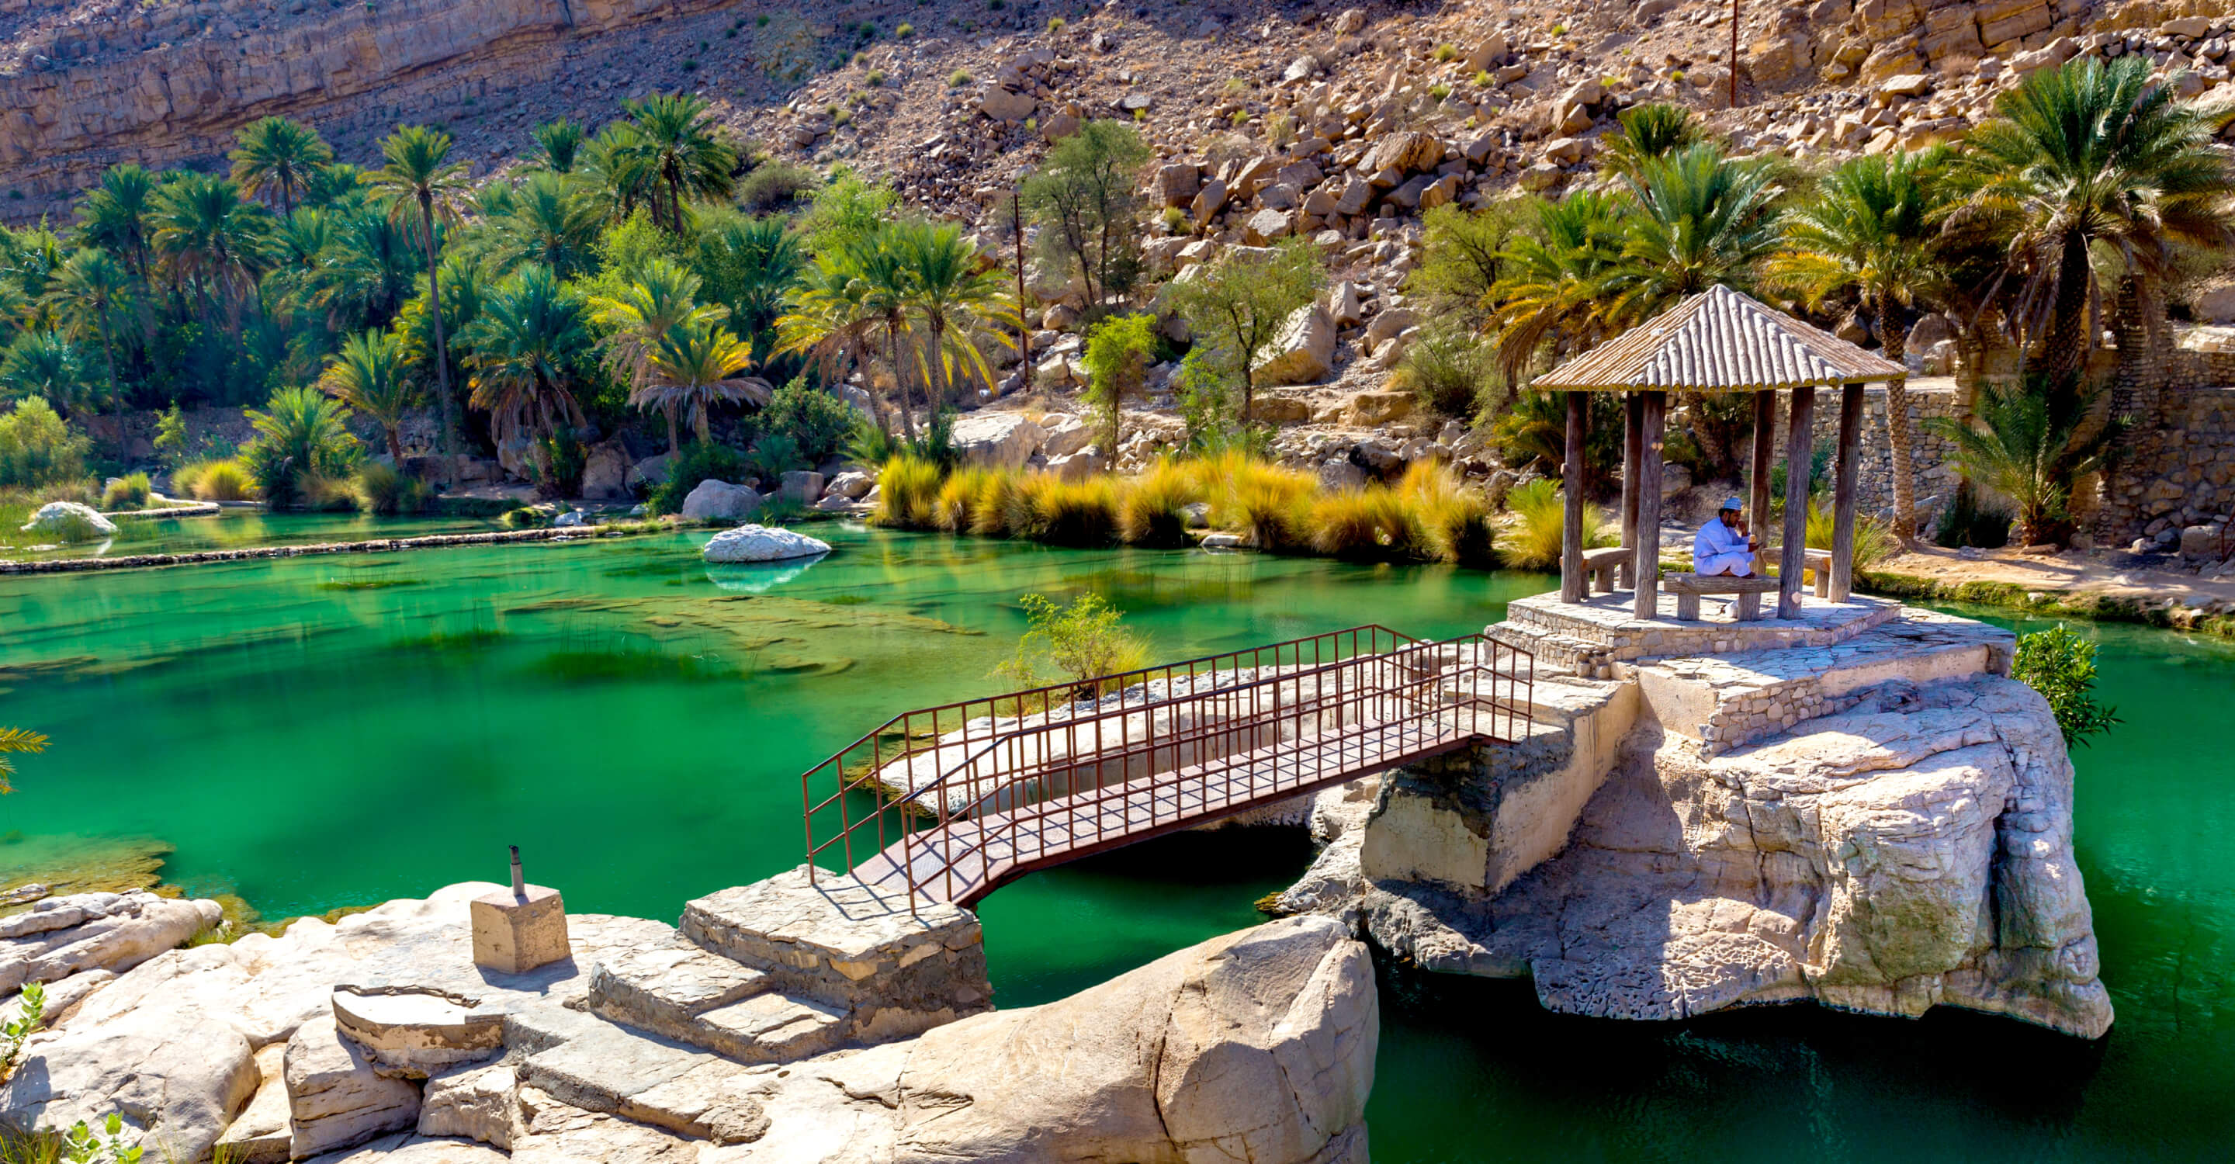

DETAILED ITINERARY

Day 1 | 12th Dec: Muscat - Coastal Wonders – Ras Al Jinz Turtle Reserve
After breakfast, your guide will meet you at your hotel in Muscat. The journey begins along the stunning coastal road towards Sur. En route, stop at Wadi Arbayeen, a hidden gem with emerald pools and dramatic cliffs, offering a perfect introduction to Oman’s natural beauty. Continue to the Bimah Sinkhole, a striking limestone crater filled with turquoise water, believed to have been created by a meteor. Next, visit Wadi Shaab, one of Oman’s most famous wadis, where a short hike through palm groves and rocky terrain leads to natural pools and waterfalls.

Arrive in Sur by afternoon and check-in at Turtle Beach Resort around 1600 hrs. Relax and enjoy the seaside ambience before dinner. Later in the evening, proceed to the Ras Al Jinz Turtle Reserve, where you will witness one of nature’s greatest spectacles – the endangered green turtles nesting on the beach under the guidance of experts.
Overnight: Turtle Beach Resort (Hamoor Room, Half Board)

Day 2 | 13th Dec: Sur – Wadi Bani Khalid – Wahiba Sands
After breakfast, explore Sur, a historic coastal town known for its maritime heritage. Visit the traditional dhow building yard, where wooden ships have been handcrafted for centuries, offering a glimpse into Oman’s seafaring past. Proceed to Wadi Bani Khalid, one of the most picturesque wadis in Oman. Here, sparkling blue-green pools are surrounded by date palms and dramatic mountains. Enjoy a refreshing swim or simply take in the tranquil surroundings.

From here, drive into the golden dunes of Wahiba Sands, one of Oman’s most famous deserts. Along the way, visit a Bedouin house to experience traditional Omani hospitality and learn about the Bedouin way of life. By late afternoon, arrive at Arabian Nights Resort and check into your Dune Villa. In the evening, venture out for a thrilling dune drive and marvel at the breathtaking sunset over the sand dunes. Dinner will be served at the resort.
Overnight: Arabian Nights Resort (Dune Villa, Half Board)

Day 3 | 14th Dec: Wahiba Sands – Muscat
Enjoy breakfast at the resort and spend the morning at leisure. You may choose to relax and make use of the resort’s facilities, take a short camel ride, or simply enjoy the tranquility of the desert. (Price can be paid directly at the resort.)

Around midday, check out and begin your journey back to Muscat, arriving by afternoon for drop-off at your hotel or Muscat International Airport.

