

NANN Global Exchange Program to Spain

Optional Cultural Extension to Barcelona
February 6-9, 2026
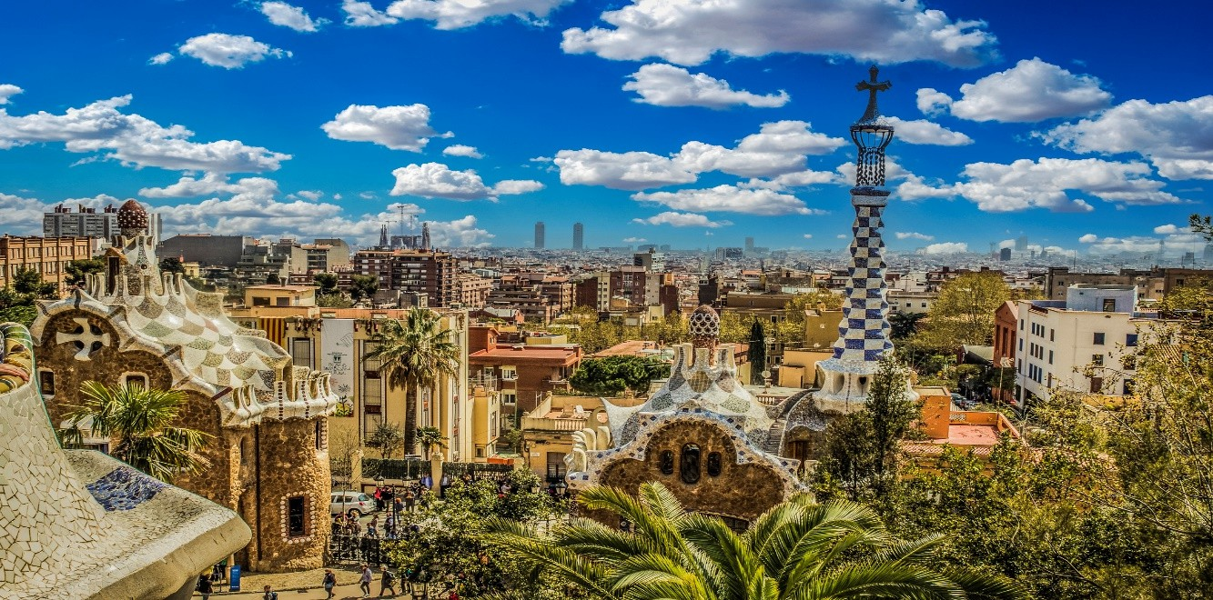

DETAILED ITINERARY

February 6, 2026 Train Madrid to Barcelona
Today, transfer in the morning from Madrid to Barcelona aboard the AVE high-speed train (approx. 3 hours). Barcelona, a city renowned for its beauty and artistic spirit, blends modernist architecture, Art Nouveau elegance, and the unmistakable energy of Catalan culture. Upon arrival, enjoy lunch at our local pick before checking in to your hotel. This afternoon, visit Casa Batlló and Casa Milà (La Pedrera), two of Antoni Gaudí’s most iconic masterpieces. Afterwards, head out on foot to explore the surrounding streets and begin soaking in the city’s unique atmosphere. Dinner at your leisure.

February 7-8, 2026 Barcelona

Over the next two days, will be filled with the sights, sounds, smells, and tastes of Barcelona. A few of the highlights of these two days include:
- Visit Sagrada Familia and enjoy exploring this icon of Barcelona. The Sagrada Familia church is the best example of Modernist architecture designed by the legendary architect Antoni Gaudi.
- Take in the impressive structure and the art nouveau architecture of the neighborhood known as the Gothic Quarter. Walk La Rambla, a bustling boulevard that captures the essence of the city’s energy and diversity.
- Discover this historic work-in-progress with construction continuing to this day ide the recently refurbished Montjuïc Cable Car for panoramic views of the city.
- Park Güell: filled with colorful mosaics, sculptures, and panoramic views of the city.
- Meals: One lunch and one dinner are included, while the other two meals are left at your leisure, giving you the opportunity to choose among many local options.
- Free Time: The program focuses all guided visits and main sites in the morning, leaving the afternoons free for you to explore on your own — shopping, museums, or simply enjoying the city at your own pace.

February 9, 2026 Departure

Depart from Josep Tarradellas Barcelona International Airport (BCN) for your return to the United States.

The program fee includes:
- High Speed Train from the final delegation hotel in Madrid to Barcelona- lunch included
- 3 nights, Accommodations at the Petit Palace Eixample 4* Hotel or similar
- Spanish English-speaking Tour Guide during the three-day program
- Meals: Breakfast daily. Two Lunches. One dinner.
- Admission fees for included program activities
- All ground transportation

Monday, November 17, 2025 Barcelona
Depart from Josep Tarradellas Barcelona International Airport (BCN) for your return to the United States.

Meals: Breakfast

HOTEL DETAILS

Hotel Petit Palace Eixample (3 Nights)
Address: Gran Via de les Corts Catalanes, 570 L'Eixample, 08011 Barcelona,
Spain Phone: +34 93 52 73 74

24-HOUR EMERGENCY CONTACT

National Guide
Mate: +34 672 39 94 70 (available on both call and WhatsApp)

