India Pre-Arrival Culture Day

Program Cost:

$310 USD, Single supplement $520

(includes one night accommodation, entry fee, local guide, private transportation)

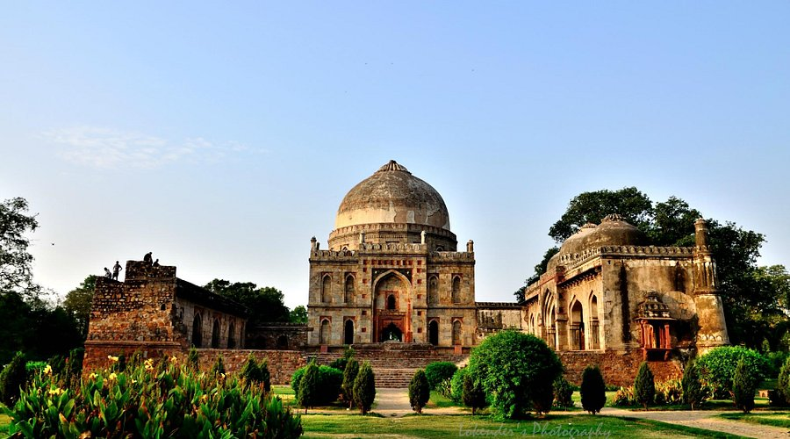
Cultural Extension Enrollment Form
Begin with a visit to Safdarjung Tomb, a graceful example of late Mughal architecture set within expansive, well-maintained gardens. The monument’s symmetry and peaceful setting create a calm and unhurried start to your exploration.
Continue to Lodhi Garden, a serene green oasis in the heart of Delhi, where historic tombs from the 15th century are scattered among shaded walkways and landscaped lawns. It is an ideal place for a leisurely stroll while experiencing the quieter side of the city.
Later, visit either the National Museum, home to an extensive collection of art, sculptures, and historical artifacts spanning thousands of years, or the Crafts Museum, where traditional Indian textiles, handicrafts, and rural artistry are beautifully showcased.
Lastly, enjoy a short drive through Connaught Place, a vibrant commercial hub known for its colonial architecture, lively atmosphere, and cafés. You may also stop briefly at Agrasen ki Baoli, a hidden stepwell tucked quietly within the city.
