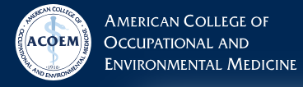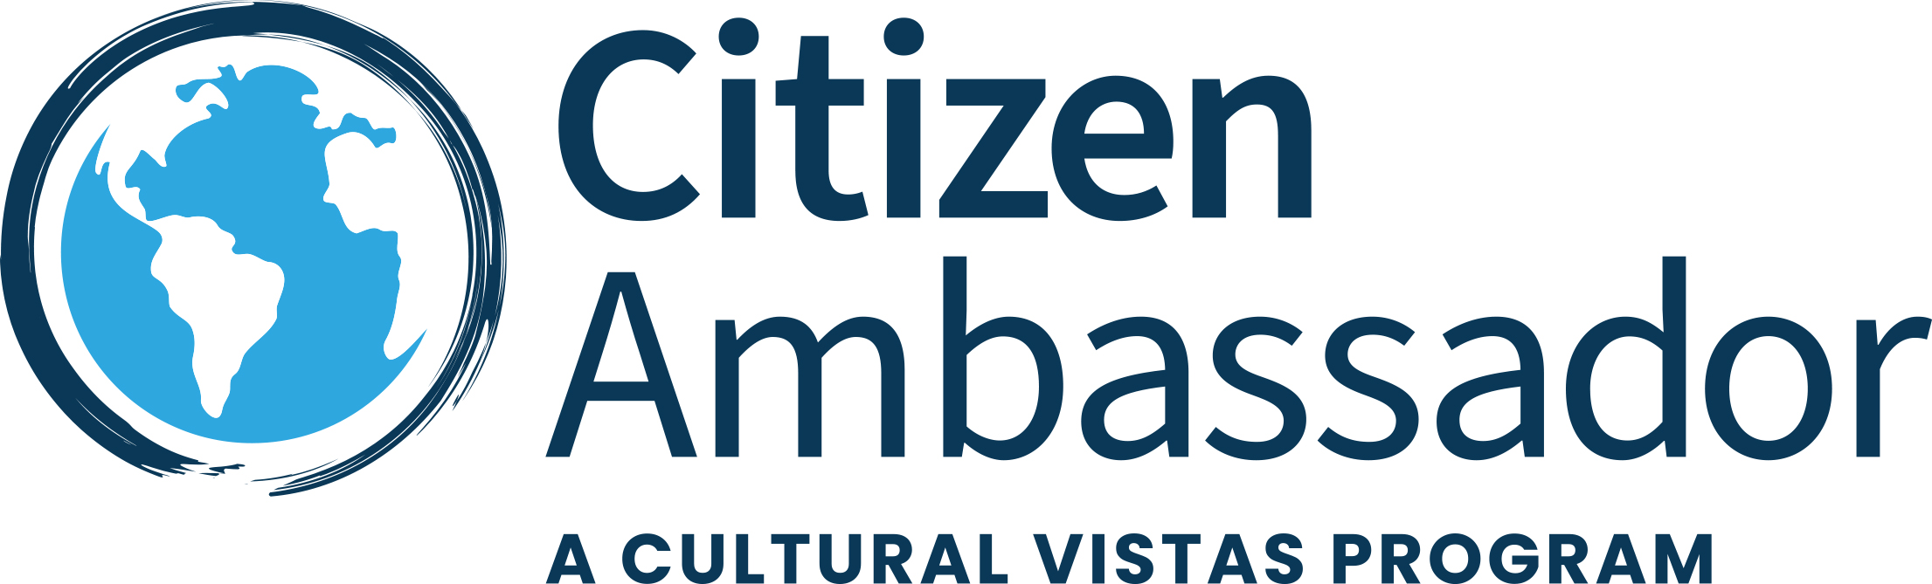

ACOEM Global Exchange Delegation to South Africa
October 24-30, 2026

Program Overview

South Africa offers a unique intersection of advanced occupational health systems and high-risk industrial sectors, providing real-world insights into regulatory frameworks, surveillance, and compensation models. This exchange enables ACOEM members to benchmark best practices, explore emerging risks, and strengthen international partnerships in occupational and environmental health.
South Africa’s Occupational and Environmental Health Areas of Interest
- High-risk industrial sectors like mining, maritime, and heavy industry, which create complex occupational health challenges such as silicosis, TB, and noise-induced hearing loss.
- Integrated national systems for surveillance and compensation, including the National Institute for Occupational Health (NIOH) and the Compensation Fund, which link workplace health data to policy and benefits.
- Dual burden of infectious and occupational diseases, requiring collaboration between occupational medicine and communicable disease control (e.g., NICD for TB and COVID-19 in workplaces).
- Strong regulatory framework under the OHS Act and COIDA, combined with specialized administrators like Rand Mutual Assurance for mining and metals.
- Global relevance: South Africa’s experience with occupational lung disease and large-scale compensation programs offers lessons for other countries managing high-risk workforces.

Through site visits, observations and discussions, the ACOEM delegation will have the opportunity to:
- Compare U.S. occupational health practices with South Africa’s integrated approach to policy, surveillance, and compensation in high-risk sectors like mining, maritime, and healthcare.
- Gain insights into innovative programs for managing occupational diseases (TB, silicosis, COVID-19) and Return-to-Work strategies in resource-intensive industries.
- Establish partnerships with NIOH, NICD, SASOM, and academic hospitals for joint studies on occupational exposures, infectious disease control, and workplace safety.
- Learn from South Africa’s training models for occupational medicine specialists and explore CPD alignment with ACOEM standards.
- Understand how South Africa integrates compensation, rehabilitation, and surveillance under COIDA and OHS Act is valuable for shaping U.S. programs and global guidelines.
- Build relationships with government authorities, industry leaders, and professional societies to strengthen ACOEM’s international footprint.

Preliminary Topics of Discussion

1. Occupational Health Policy & Governance
- South Africa’s regulatory framework: Occupational Health and Safety Act and Compensation for Occupational Injuries and Diseases Act (COIDA).
- Roles of national, provincial, and municipal authorities in workplace health and safety oversight.

2. Clinical Practice & Hospital-Based Occupational Medicine
- Management of occupational diseases (e.g., respiratory disorders, TB, allergies).
- Integration of occupational health into tertiary care and trauma systems.
- Training pathways for occupational medicine specialists.

3. Surveillance, Research & Laboratory Capacity
- National surveillance systems for occupational diseases.
- Laboratory diagnostics for occupational exposures (toxicology, immunology, genotoxicity).
- Infection control and outbreak response for healthcare workers.

4. Workplace Safety & Environmental Health
- Risk-based safety management systems in industrial and port operations.
- SHE (Safety, Health, Environment) compliance and contractor management.
- Environmental health programs at municipal level (air, water, hazardous substances).

5. Workers’ Compensation & Rehabilitation
- COIDA administration and claims processes.
- Return-to-work programs and rehabilitation for injured workers.
- Lessons from mining-related diseases (silicosis, TB) and pandemic-related claims.

Day 1: Saturday, October 24, 2026 | Cape Town Arrival Day
Delegates will arrive throughout the day at Cape Town International Airport and will be transferred to the hotel.

Cape Town, South Africa’s coastal gem, is renowned for its stunning natural beauty and cultural diversity. Nestled between Table Mountain and the Atlantic Ocean, the city offers breathtaking landscapes, vibrant neighbourhoods, and rich history. From exploring Robben Island to strolling through the V&A Waterfront, Cape Town captivates with its charm, wildlife, cuisine, and warm, welcoming spirit.

The remainder of the day is at leisure to allow you to settle into your new home away from home experience.

***Dinner is by individual arrangement (own expense).
Overnight: Southern Sun Waterfront
Meals: None

Day 2: Sunday, October 25, 2026 | Cape Town Cultural Program
In the morning 08:15-9:00 AM, the delegation will convene for an orientation and cultural briefing conducted by your Delegation Manager. This session will provide essential context on South Africa’s historical, cultural, and socio-political landscape, as well as important logistical details for the days ahead—laying the foundation for a purposeful and informed visit.

Following the briefing, enjoy a full-day guided cultural tour of Cape Town.

Begin with a visit to Robben Island, a UNESCO World Heritage Site and enduring symbol of South Africa’s struggle for democracy. Famously described by Nelson Mandela as “the harshest, most iron-fisted outpost in the South African penal system,” the island has served a range of functions throughout history—from leprosy hospital and military base to a maximum-security prison for political dissidents. Today, it operates as a museum offering a powerful perspective on the country’s journey to freedom. The visit includes a ferry transfer from the V&A Waterfront and a guided tour of approximately four hours (weather permitting).

***Lunch is by individual arrangement (own expense).

In the afternoon, the delegation will continue with a guided cultural walk through Bo-Kaap, one of Cape Town’s most historically significant neighborhoods. Known for its distinctive architecture and vibrant community, Bo-Kaap is a center of Cape Malay heritage and one of the few areas in Cape Town not subjected to forced removals during Apartheid. The visit highlights the district’s Islamic cultural legacy, its origins as a settlement for freed slaves, and the challenges it currently faces due to urban gentrification. The walk also explores the rise of community-based tourism and homegrown entrepreneurship in response to shifting economic realities.

In the evening, the group will reconvene for a formal welcome dinner, providing an opportunity for delegates to connect and reflect on the day’s experiences in a convivial setting.
Overnight: Southern Sun Waterfront
Meals: Breakfast & Dinner

Day 3: Monday, October 26, 2026 | Cape Town Professional Program

10:00 to 12:00 HRS: Morning Meeting with University of Cape Town
The Division of Occupational Medicine is a joint division of the School of Public Health and the Department of Medicine of the University of Cape Town. The Division supports:
- Groote Schuur Hospital Staff Occupational Health Service in the surveillance, management and prevention of occupational ill-health among hospital staff via a registrar placement and consultant support.
- The Division serves as a unit for the training of occupational medicine specialists through the MMed Occupational Medicine programme in the School of Public Health.

14:00 to 16:00 HRS: Afternoon Meeting with Ms. Zahida Sonday - Occupational Medicine Specialist
Overnight: Southern Sun Waterfront
Meals: Breakfast & Dinner

Day 4: Tuesday, October 27, 2026 | Flight to Johannesburg
Morning at leisure

***Lunch is by individual arrangement (own expense).
12:30 - Depart the hotel / city after the morning meeting
13:00 - Arrive at Cape Town International Airport
13:20 - Group check-in
14:50 - Boarding commences
15:20 - Flight departs
Airlink 4Z924
Cape Town (CPT) → Johannesburg (JNB)
Departure: 15:20
Arrival: 17:25

Dinner will be served in the evening.

Overnight: Southern Sun Sandton
Meals: Breakfast & Dinner

Day 5: Wednesday, October 28, 2026 | Johannesburg Professional Program

09:00 – 14:00 HRS: Meeting with National Institute of Occupational Health (NIOH)
The National Health Laboratory Service’s (NHLS) Institute for Occupational Health (NIOH), is recognised internationally for excellence in research, services and training to support occupational health services not only in South Africa but also in Southern Africa through its extensive outreach activities and collaborations.

Lunch will be hosted by NIOH

15:00 HRS - Meeting with South African Society of Occupational Medicine SASOM at Southern Sun Sandton Boardroom
The South African Society of Occupational Medicine (SASOM) is dedicated to the advancement of occupational medicine and health practices across industries. As a leading voice in occupational medicine, SASOM brings together a network of professionals committed to ensuring a safer, healthier, and more productive workforce.

Overnight: Southern Sun Sandton
Meals: Breakfast & Dinner

Day 6: Thursday, October 29, 2026 | Johannesburg Professional Program

09:00 – 12:00 HRS: Site Visit of Charlotte Maxeke Academic Hospital

Lunch will be served in the afternoon.

Following lunch, visit the Apartheid Museum, one of South Africa’s most significant institutions. The museum presents a powerful chronicle of the rise and fall of apartheid through a compelling series of 22 exhibition areas. Utilizing impactful film footage, photographs, personal testimonies, and historical artifacts, the experience provides an emotional and thought-provoking journey through the nation’s past. Designed with intentional spatial flow and symbolism, the museum fosters a deeper understanding of the apartheid system and South Africa’s ongoing path toward reconciliation and democracy. While the visit is self-paced, delegates are encouraged to engage with the exhibits at their own comfort, knowing that the depth of the museum often warrants return visits.

Explore Soweto (South Western Townships) by tuk-tuk—a dynamic and engaging way to connect with the community and experience everyday life in this historically rich area.

Soweto, now considered South Africa’s largest urban settlement, played a pivotal role in the anti-apartheid movement and remains a vibrant symbol of hope and activism. Highlights of the tour include Kliptown, where the Freedom Charter was adopted; Vilakazi Street, the only street in the world to have housed two Nobel Peace Prize laureates—Nelson Mandela and Archbishop Desmond Tutu; and the poignant Hector Pieterson Memorial, commemorating the 1976 student uprisings.

As you journey through various township neighborhoods, you will witness the striking contrasts that define Soweto today: informal settlements beside modern homes, shacks next to mansions, lush gardens amid littered streets, and sleek shopping malls alongside street vendors. This experience reveals a community of resilience, cultural richness, and dynamic transformation.

In the evening, gather for a farewell dinner, offering time to reflect on the journey and share final moments together as a group.
Overnight: Southern Sun Sandton
Meals: Breakfast, Lunch & Dinner

Day 7: Friday, October 30, 2026 | Johannesburg Departure

